EXPERIMENT 4

AIM: Working with Docker Network  
Steps to Complete:  
Step 1 - Create Network  
The first step is to create a network using the CLI. This network will allow us to attach multiple containers which will be able to discover each other.  
In this example, we're going to start by creating a backend-network. All containers attached  
to our backend will be on this network.

**Task:** Create Network  
To start with we create the network with our predefined name.  
docker network create backend-network.

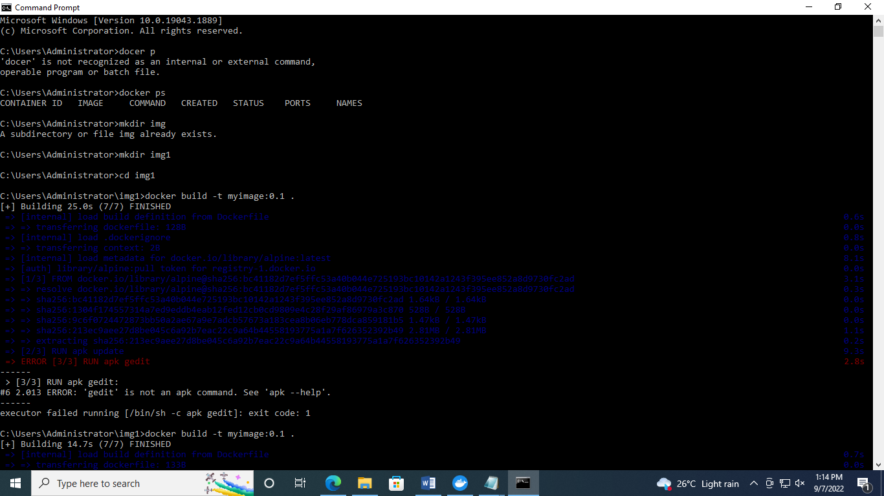

Step 2 - Network Communication  
Unlike using links, docker network behave like traditional networks where nodes can be attached/detached.

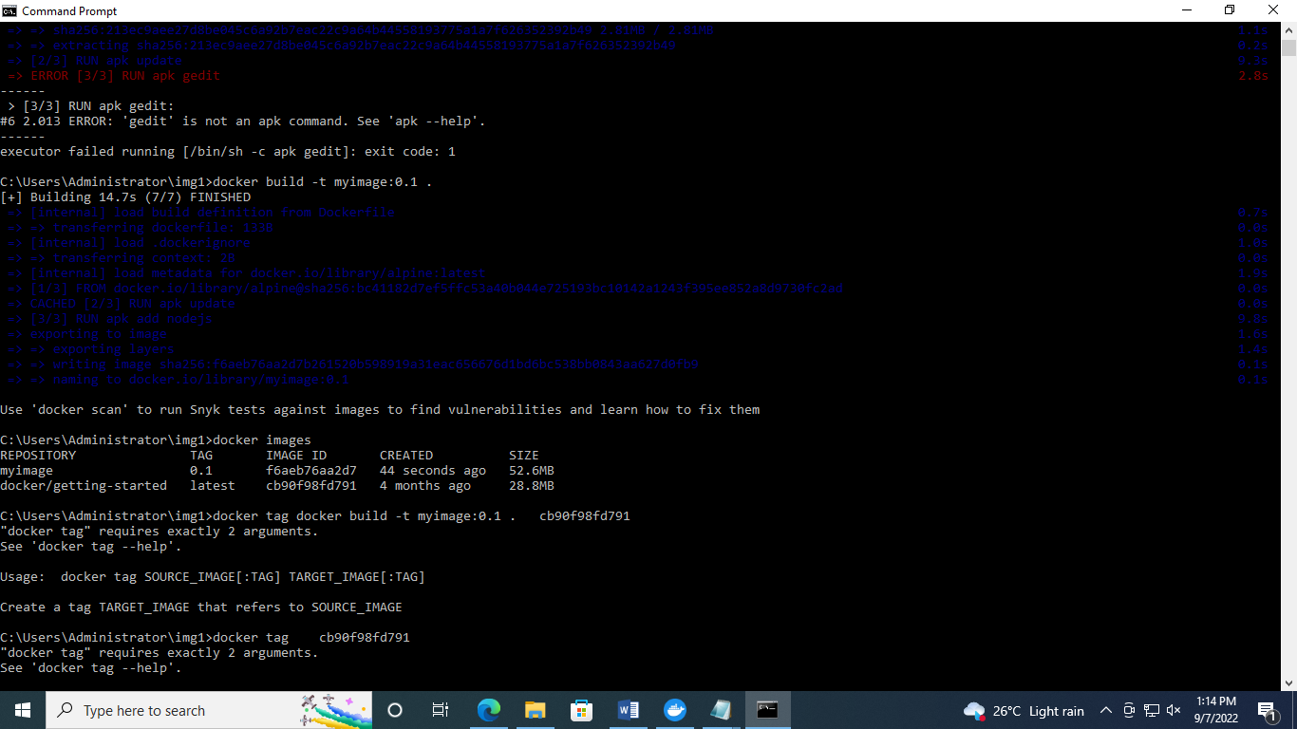

Step 3 - Connect Two Containers Task  
The first task is to create a new network in the same way.  
docker network create frontend-network.  
**docker network connect frontend-network redis**  
**docker run -d -p 3000:3000 --net=frontend-network katacoda/redis-node-docker-example.  
 curl docker:3000.**

Step 4 - Create Aliases

Connect Container with Alias  
The following command will connect our Redis instance to the frontend-network with the  
alias of db.  
**docker network create frontend-network2  
docker network connect --alias db frontend-network2 redis.**

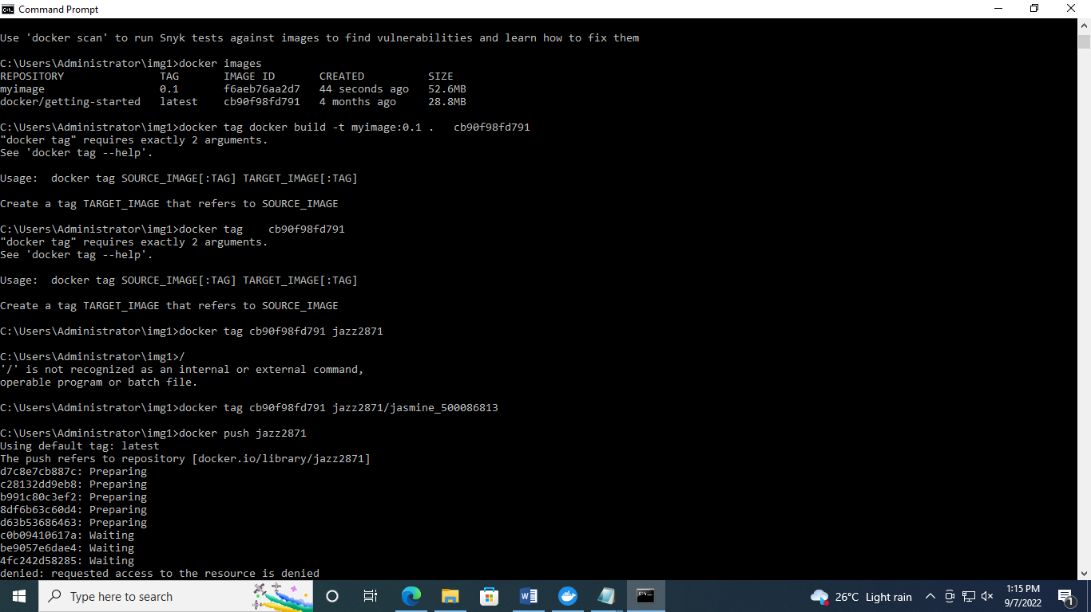

Step 5 - Disconnect Containers  
